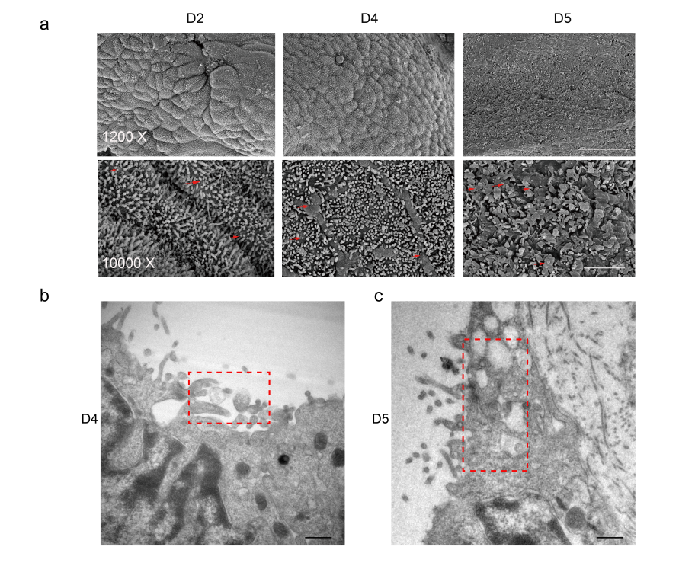
Figure S1. Small extracellular vesicles (sEVs) were secreted by endometrium during implantation. a SEM images shown the morphology of endometrial surface in D2, D4 and D5 on pregnant mouse. Red arrows show the vesicles on the surface of endometrial epithelium similar to sEVs. Bar, 1200x: 30μm, 10000X: 3μm. Electron microscopic images of sEVs in endometrium on D4 (b) and D5 (c) . Red box indicated sEVs.

